

**SOFTWARE REQUIREMENT SPECIFICATION**

**<<Project Name – Project Code>>**

**Team Contributions**

|  |  |  |
| --- | --- | --- |
| ***#*** | ***Full Name*** | ***In charge*** |
| 1 | Ngô Anh Tú |  |
| 2 | Lê Trung Sang |  |
| 3 | Trần Xuân Sơn |  |
| 4 | Bùi Đình Chung |  |
| 5 | Bùi Duy Khải |  |
|  |  |  |

– Hanoi, August 2019 –

**TABLE OF CONTENT**

Contents

I. Business Requirements 3

1. Business Requirements 3

1.1 Background 3

1.2 Business Opportunity 3

1.3 Assumptions & Dependencies 4

2. Scope and Limitations 4

2.1 Major Features 4

2.2 Scope of Product Releases 5

2.3 Limitations & Exclusions 5

II. User Requirements 6

1. Overall Description 6

1.1 User Classes (Actors) 6

1.2 Features Tree 7

1.3 User Case Diagram 8

1.4 Use Cases List 8

1.5 Business Rules 9

2. Order Meals Feature 10

2.1 Order a Meal 10

2.2 Change Meal Order 11

2.3 Cancel Meal Order 11

3. Meal Subscriptions Feature 12

3.1 Register for Payroll Deduction 12

3.2 <<Next Use Case Name..>> 12

4. <<Next Feature Name..>> 12

4.1 <<Use Case Name>> 12

4.2 … 12

# I. Business Requirements

## 1. Business Requirements

*<<The business requirements provide the foundation and reference for all detailed requirements development. You may gather business requirements from the customer or development organization’s senior management, an executive sponsor, a project visionary, product management, the marketing department, or other individuals who have a clear sense of why the project is being undertaken and the ultimate value it will provide, both to the business and to customers.>>*

<<Sample:

Employees at the company Process Impact presently spend an average of 65 minutes per day going to the cafeteria to select, purchase, and eat lunch. About 20 minutes of this time is spent walking to and from the cafeteria, selecting their meals, and paying by cash or credit card. When employees go out for lunch, they spend an average of 90 minutes off-site. Some employees phone the cafeteria in advance to order a meal to be ready for them to pick up. Employees don’t always get the selections they want because the cafeteria runs out of certain items. The cafeteria wastes a significant quantity of food that is not purchased and must be thrown away. These same issues apply to breakfast and supper, although far fewer employees use the cafeteria for those meals than for lunch.

>>

### 1.1 Background

*<<This section summarizes the rationale for the new product. Provide a general description of the history or situation that leads to the recognition that this product should be built.>>*

<<Sample:

Employees at the company Process Impact presently spend an average of 65 minutes per day going to the cafeteria to select, purchase, and eat lunch. About 20 minutes of this time is spent walking to and from the cafeteria, selecting their meals, and paying by cash or credit card. When employees go out for lunch, they spend an average of 90 minutes off-site. Some employees phone the cafeteria in advance to order a meal to be ready for them to pick up. Employees don’t always get the selections they want because the cafeteria runs out of certain items. The cafeteria wastes a significant quantity of food that is not purchased and must be thrown away. These same issues apply to breakfast and supper, although far fewer employees use the cafeteria for those meals than for lunch.

>>

### 1.2 Business Opportunity

*<<Describe the market opportunity that exists or the business problem that is being solved. Describe the market in which a commercial product will be competing or the environment in which an information system will be used. This may include a brief comparative evaluation of existing products and potential solutions, indicating why the proposed product is attractive. Identify the problems that cannot currently be solved without the product, and how the product fits in with market trends or corporate strategic directions.>>*

<<Sample:

Many employees have requested a system that would permit a cafeteria user to order meals (defined as a set of one or more food items selected from the cafeteria menu) on line, to be picked up at the cafeteria or delivered to a company location at a specified time and date. Such a system would save employees time, and it would increase the chance of their getting the items they prefer. Knowing what food items customers want in advance would reduce wastage in the cafeteria and would improve the efficiency of cafeteria staff. The future ability for employees to order meals for delivery from local restaurants would make a wide range of choices available to employees and provide the possibility of cost savings through volume discount agreements with the restaurants.

>>

### 1.3 Assumptions & Dependencies

*<<Record any assumptions that were made when conceiving the project and writing this vision and scope document. Note any major dependencies the project must rely upon for success, such as specific technologies, third-party vendors, development partners, or other business relationships.>>*

<<Sample:

AS-1: Systems with appropriate user interfaces will be available for cafeteria employees to process the expected volume of meals ordered.

AS-2: Cafeteria staff and vehicles will be available to deliver all meals for specified delivery time slots within 15 minutes of the requested delivery time.

DE-1: If a restaurant has its own on-line ordering system, the Cafeteria Ordering System must be able to communicate with it bi-directionally.

>>

## 2. Scope and Limitations

*<<The project scope defines the concept and range of the proposed solution. It’s also important to define what will not be included in the product. Clarifying the scope and limitations helps to establish realistic expectations of the many stakeholders. It also provides a reference frame against which proposed features and requirements changes can be evaluated. Proposed requirements that are out of scope for the envisioned product must be rejected, unless they are so beneficial that the scope should be enlarged to accommodate them (with accompanying changes in budget, schedule, and/or resources).>>*

### 2.1 Major Features

*<<Include a numbered list of the major features of the new product, emphasizing those features that distinguish it from previous or competing products. Specific user requirements and functional requirements may be traced back to these features.>>*

<<Sample:

FE-01: Order and pay for meals from the cafeteria menu to be picked up or delivered.

FE-02: Order and pay for meals from local restaurants to be delivered.

FE-03: Create, view, modify, and cancel meal subscriptions for standing or recurring meal orders, or for daily special meals.

FE-04: Create, view, modify, delete, and archive cafeteria menus.

FE-05: View ingredient lists and nutritional information for cafeteria menu items.

FE-06: Provide system access through corporate intranet, smartphone, tablet, and outside Internet access by authorized employees

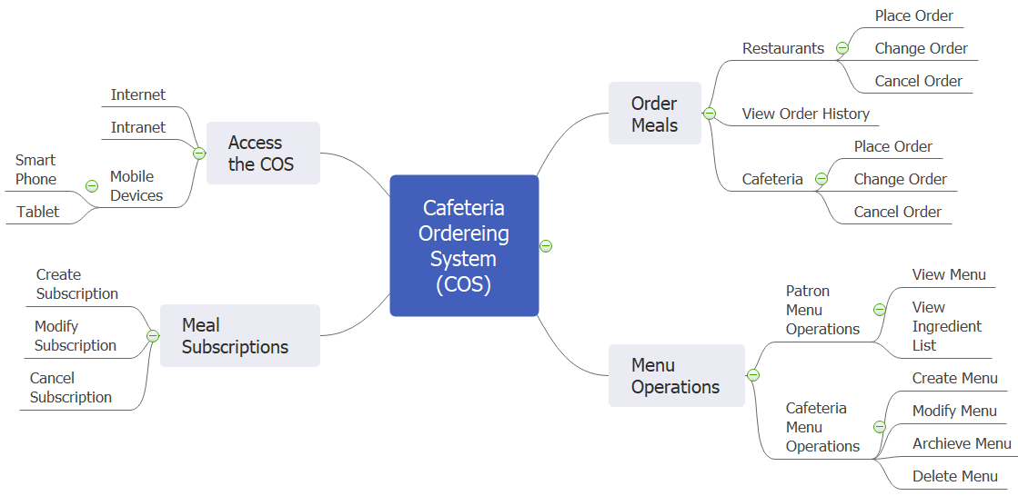

>>

### 2.2 Scope of Product Releases

*<<Describe the intended major features that will be included in the product releases. Consider the benefits the product is intended to bring to the various customer communities, and generally describe the product features and quality characteristics that will enable it to provide those benefits. Avoid the temptation to include every possible feature that any potential customer category might conceivably want some day. Focus on those features and product characteristics that will provide the most value, at the most acceptable development cost, to the broadest community.>>*

<<Sample:

|  |  |  |  |
| --- | --- | --- | --- |
| Feature | Release 1 | Release 2 | Release 3 |
| FE-01, Order from cafeteria | Standard meals from lunch menu only; meal orders for delivery can be paid for only by payroll deduction | Accept credit and debit card payments | Accept meal orders for breakfasts and suppers |
| FE-02, Order from restaurants | Not implemented | Delivery to campus locations only | Fully implemented |
| FE-03, Meal subscriptions | Not implemented | Implemented if time permits | Fully implemented |
| FE-04, Menus | Create and view menus | Modify, delete, and archive menus |  |
| FE-05, Ingredient lists | Not implemented | Fully implemented |  |
| FE-06, System access | Intranet and outside Internet access | iOS and Android phone and tablet apps | Windows Phone and tablet apps |

>>

### 2.3 Limitations & Exclusions

*<<Identify any product features or characteristics that a stakeholder might anticipate, but which are not planned to be included in the new product.>>*

<<Sample:

LI-1: Some food items that are available from the cafeteria will not be suitable for delivery, so the menus available to patrons of the COS must be a subset of the full cafeteria menus.

LI-2: The COS shall be used only for the cafeteria at the Process Impact campus in Clackamas, Oregon.

>>

# II. User Requirements

## 1. General Requirements

### 1.1 User Classes (Actors)

*<<Identify the various user classes that you anticipate will use this product and describe their pertinent characteristics. Some requirements might pertain only to certain user classes. Identify the favoured user classes. User classes represent a subset of the stakeholders described in the vision and scope document. User class descriptions are a reusable resource. If available, you can incorporate user class descriptions by simply pointing to them in a master user class catalogue instead of duplicating information here.>>*

<<Sample:

|  |  |
| --- | --- |
| Patron (favoured) | A Patron is a Process Impact employee who wants to order meals to be delivered from the company cafeteria. There are about 600 potential Patrons, of which 300 are expected to use the COS an average of 5 times per week each. Patrons will sometimes order multiple meals for group events or guests. An estimated 60 percent of orders will be placed using the corporate Intranet, with 40 percent of orders being placed from home or by smartphone or tablet apps. |
| Cafeteria Staff | The Process Impact cafeteria employs about 20 Cafeteria Staff, who will receive orders from the COS, prepare meals, package them for delivery, and request delivery. Most of the Cafeteria Staff will need training in the use of the hardware and software for the COS. |
| Menu Manager | The Menu Manager is a cafeteria employee who establishes and maintains daily menus of the food items available from the cafeteria. Some menu items may not be available for delivery. The Menu Manager will also define the cafeteria’s daily specials. The Menu Manager will need to edit existing menus periodically. |
| Meal Deliverer | As the Cafeteria Staff prepare orders for delivery, they will issue delivery requests to a Meal Deliverer's smartphone. The Meal Deliverer will pick up the food and deliver it to the Patron. A Meal Deliverer’s other interactions with the COS will be to confirm that a meal was (or was not) delivered. |

>>

### 1.2 Features Tree

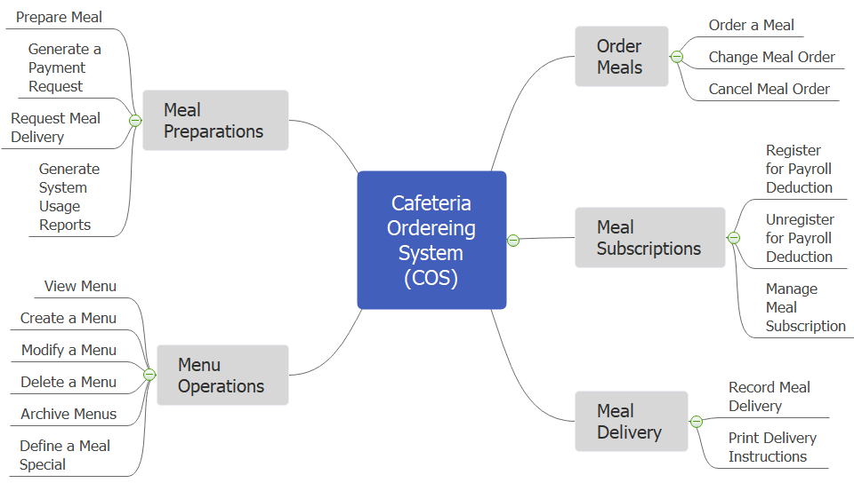

### 1.3 User Case Diagram

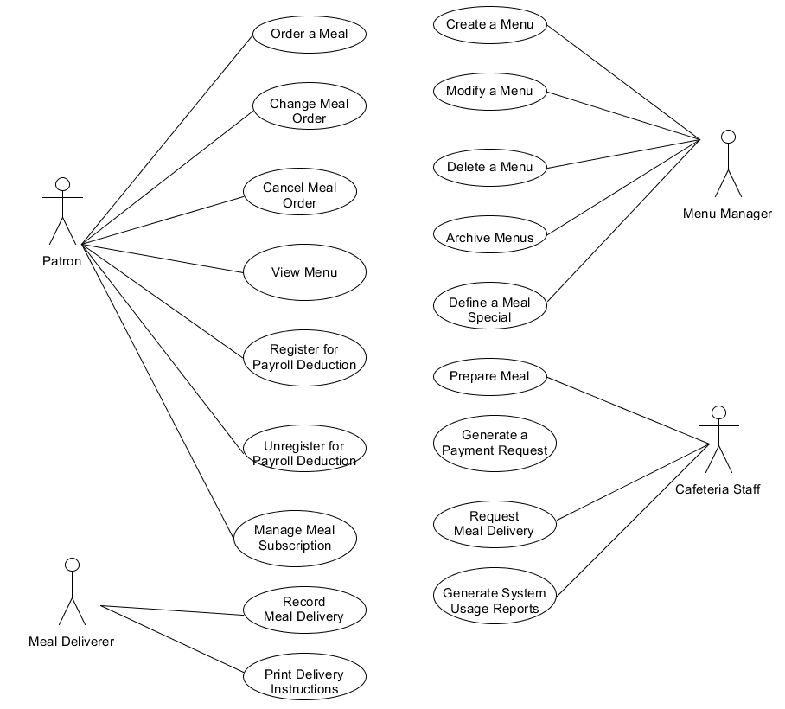

### 1.4 Use Cases List

|  |  |  |  |  |
| --- | --- | --- | --- | --- |
| **ID** | **Feature** | **Use Case** | **Primary Actors** | **Secondary Actors** |
| 01 | Order Meals | Order a Meal |  |  |
| 02 | Order Meals | Change Meal Order |  |  |
| 03 | Order Meals | Cancel Meal Order |  |  |
| 04 | Meal Subscriptions | Register for Payroll Deduction |  |  |
| 05 | Meal Subscriptions | Unregister for Payroll Deduction |  |  |
| 06 | Meal Subscriptions | Manage Meal Subscription |  |  |
| 07 | Menu Operations | View Menu |  |  |
| 08 | Menu Operations | Create a Menu |  |  |
| 09 | Menu Operations | Modify a Menu |  |  |
| 10 | Menu Operations | Delete a Menu |  |  |
| 11 | Menu Operations | Archive Menus |  |  |
| 12 | Menu Operations | Define a Meal Special |  |  |
| 13 | Meal Preparations | Prepare Meal |  |  |
| 14 | Meal Preparations | Generate a Payment Request |  |  |
| 15 | Meal Preparations | Request Meal Delivery |  |  |
| 16 | Meal Preparations | Generate System Usage Reports |  |  |
| 17 | Meal Delivery | Record Meal Delivery |  |  |
| 18 | Meal Delivery | Print Delivery Instructions |  |  |

### 1.5 Business Rules

|  |  |  |  |  |
| --- | --- | --- | --- | --- |
| ID | Rule Definition | Type of Rule | Static or Dynamic | Source |
| BR-01 | Delivery time windows are 15 minutes, beginning on each quarter hour. | Fact | Dynamic | Cafeteria Manager |
| BR-02 | Deliveries must be completed between 10:00 A.M. and 2:00 P.M. local time, inclusive. | Constraint | Dynamic | Cafeteria Manager |
| BR-03 | All meals in a single order must be delivered to the same location. | Constraint | Static | Cafeteria Manager |
| BR-04 | All meals in a single order must be paid for by using the same payment method. | Constraint | Static | Cafeteria Manager |
| BR-11 | If an order is to be delivered, the patron must pay by payroll deduction. | Constraint | Dynamic | Cafeteria Manager |
| BR-12 | Order price is calculated as the sum of each food item price times the quantity of that food item ordered, plus applicable sales tax, plus a delivery charge if a meal is delivered outside the free delivery zone. | Computation | Dynamic | cafeteria policy; state tax code |
| BR-24 | Only cafeteria employees who are designated as Menu Managers by the Cafeteria Manager can create, modify, or delete cafeteria menus. | Constraint | Static | cafeteria policy |
| BR-33 | Network transmissions that involve financial information or personally identifiable information require 256-bit encryption. | Constraint | Static | corporate security policy |
| BR-86 | Only regular employees can register for payroll deduction for any company purchase. | Constraint | Static | Corporate Accounting Manager |
| BR-88 | An employee can register for payroll deduction payment of cafeteria meals if no more than 40 percent of his gross pay is currently being deducted for other reasons. | Constraint | Dynamic | Corporate Accounting Manager |

## 2. Order Meals Feature

### 2.1 Order a Meal

|  |  |  |  |
| --- | --- | --- | --- |
| ID and Name: | **UC-01 Order a Meal** | | |
| Created By: | Prithvi Raj | Date Created: | 10/4/13 |
| Primary Actor: | Patron | Secondary Actors: | Cafeteria Inventory System |
| Description: | A Patron accesses the Cafeteria Ordering System from the corporate intranet or from home, views the menu for a specific date if desired, selects food items, and places an order for a meal to be delivered to a specified location within a specified 15-minute time window. | | |
| Trigger: | A Patron indicates that he wants to order a meal | | |
| Preconditions: | PRE-1. Patron is logged into COS.  PRE-2. Patron is registered for meal payments by payroll deduction. | | |
| Postconditions: | POST-1. Meal order is stored in COS with a status of “Accepted”.  POST-2. Inventory of available food items is updated to reflect items in this order.  POST-3. Remaining delivery capacity for the requested time window is updated. | | |
| Normal Flow: | **1.0 Order a Single Meal**   1. Patron asks to view menu for a specific date. (see 1.0.E1, 1.0.E2) 2. COS displays menu of available food items and the daily special. 3. Patron selects one or more food items from menu. (see 1.1) 4. Patron indicates that meal order is complete. (see 1.2) 5. COS displays ordered menu items, individual prices, and total price, including taxes and delivery charge. 6. Patron either confirms meal order (continue normal flow) or requests to modify meal order (return to step 2). 7. COS displays available delivery times for the delivery date. 8. Patron selects a delivery time and specifies the delivery location. 9. Patron specifies payment method. 10. COS confirms acceptance of the order. 11. COS sends Patron an email message confirming order details, price, and delivery instructions. 12. COS stores order, sends food item information to Cafeteria Inventory System, and updates available delivery times. | | |
| Alternative Flows: | **1.1 Order multiple identical meals**   1. Patron requests a specified number of identical meals. (see 1.1.E1) 2. Return to step 4 of normal flow.   **1.2 Order multiple meals**   1. Patron asks to order another meal. 2. Return to step 1 of normal flow. | | |
| Exceptions: | **1.0.E1 Requested date is today and current time is after today’s order cutoff time**  1. COS informs Patron that it’s too late to place an order for today.  2a. If Patron cancels the meal ordering process, then COS terminates use case.  2b. Else if Patron requests another date, then COS restarts use case.  **1.0.E2 No delivery times left**  1. COS informs Patron that no delivery times are available for the meal date.  2a. If Patron cancels the meal ordering process, then COS terminates use case.  2b. Else if Patron requests to pick the order up at the cafeteria, then continue with normal flow, but skip steps 7 and 8.  **1.1.E1 Insufficient inventory to fulfill multiple meal order**  1. COS informs Patron of the maximum number of identical meals he can order, based on current available inventory.  2a. If Patron modifies number of meals ordered, then Return to step 4 of normal flow.  2b. Else if Patron cancels the meal ordering process, then COS terminates use case. | | |
| Priority: | High | | |
| Frequency of Use: | Approximately 300 users, average of one usage per day. Peak usage load for this use case is between 9:00 A.M. and 10:00 A.M. local time. | | |
| Business Rules: | BR-1, BR-2, BR-3, BR-4, BR-11, BR-12, BR-33 | | |
| Other Information: | 1. Patron shall be able to cancel the meal ordering process at any time prior to confirming it. 2. Patron shall be able to view all meals he ordered within the previous six months and repeat one of those meals as the new order, provided that all food items are available on the menu for the requested delivery date. (Priority = M) 3. The default date is the current date if the Patron is using the system before today’s order cutoff time. Otherwise, the default date is the next day that the cafeteria is open. | | |
| Assumptions: | Assume that 15 percent of Patrons will order the daily special (source: previous 6 months of cafeteria data). | | |

### 2.2 Change Meal Order

*<<Use Case Description in the same format as above>>*

### 2.3 Cancel Meal Order

*<<Use Case Description in the same format as above>>*

## 3. Meal Subscriptions Feature

### 3.1 Register for Payroll Deduction

|  |  |  |  |
| --- | --- | --- | --- |
| ID and Name: | **UC-05 Register for Payroll Deduction** | | |
| Created By: | Nancy Anderson | Date Created: | 9/15/13 |
| Primary Actor: | Patron | Secondary Actors: | Payroll System |
| Description: | Cafeteria patrons who use the COS and have meals delivered must be registered for payroll deduction. For noncash purchases made through the COS, the cafeteria will issue a payment request to the Payroll System, which will deduct the meal costs from the next scheduled employee payday direct deposit. | | |
| Trigger: | Patron requests to register for payroll deduction, or Patron says yes when COS asks if he wants to register | | |
| Preconditions: | PRE-1. Patron is logged into COS. | | |
| Postconditions: | POST-2. Patron is registered for payroll deduction. | | |
| Normal Flow: | **5.0 Register for Payroll Deduction**   1. COS asks Payroll System if Patron is eligible to register for payroll deduction. 2. Payroll System confirms that Patron is eligible to register for payroll deduction. 3. COS asks Patron to confirm his desire to register for payroll deduction. 4. If so, COS asks Payroll System to establish payroll deduction for Patron. 5. Payroll System confirms that payroll deduction is established. 6. COS informs Patron that payroll deduction is established. | | |
| Alternative Flows: | None | | |
| Exceptions: | 5.0.E1 Patron is not eligible for payroll deduction  5.0.E2 Patron is already enrolled for payroll deduction | | |
| Priority: | High | | |
| Frequency of Use: |  | | |
| Business Rules: | BR-86 and BR-88 govern an employee’s eligibility to enroll for payroll deduction. | | |
| Other Information: | Expect high frequency of executing this use case within first 2 weeks after system is released. | | |
| Assumptions: |  | | |

### 3.2 <<Next Use Case Name..>>

*<<Use Case Description in the same format as above>>*

## 4. <<Next Feature Name..>>

### 4.1 <<Use Case Name>>

*<<Use Case Description in the same format as above>>*

### 4.2 …

////////////////

# III. Functional Requirement

## 1. Overall Description

### 1.1 Screen Flow

*<<Draw the flow of software screens like the sample below. If your developing software is not screen-based application, then you can use equivalent diagrams to represent>>*

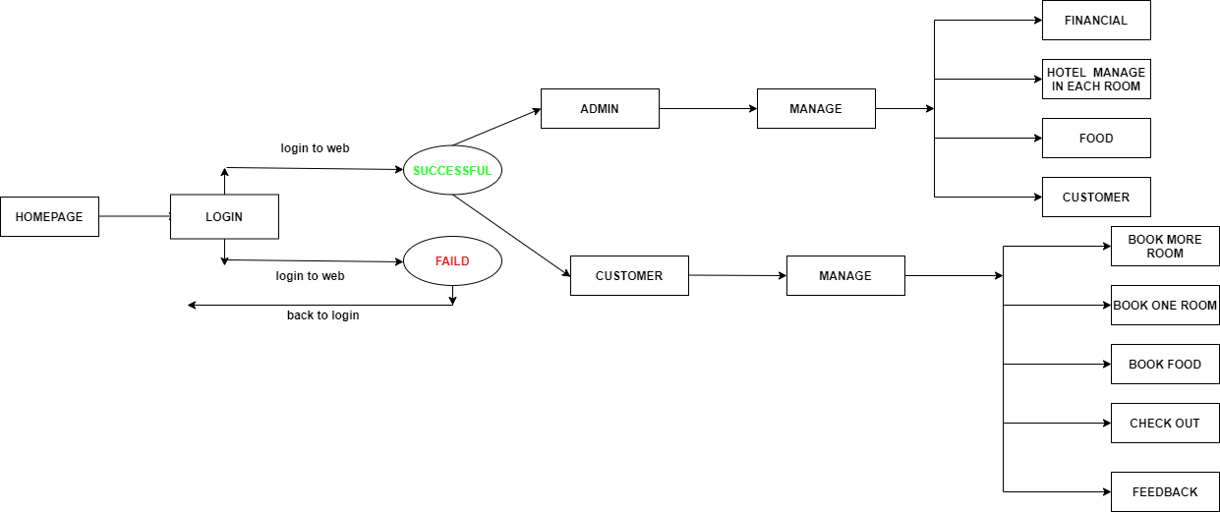

### 1.2 System Functions

|  |  |  |  |
| --- | --- | --- | --- |
| **ID** | **Feature** | **Screen/Function** | **Description** |
| 01 | Customer's Info | Manager | Manage infomation of customer |
| 02 | Management hotel room in each unit | Manager | Manage all info about room |
| 03 | Financial management | Manager | Manage financial of hotel |
| 04 | Furniture management | Manager | Manage funiture of hotel |
| 05 | Sign in | User | User can log in |
| 06 | Book food | User | User can book food |
| 07 | Book Room | User | User can book room |
| 08 | More Book Rooms | User | User can More Book Rooms after book one room |
| 09 | Check out | User | Make payment, check out |
| 10 | Feedback | User | Give your own opinion |

### 1.3 System Authorization

The access rights to the screens and screens’ activity are as below

|  |  |  |
| --- | --- | --- |
| **Screen** | **Role1** | **Role 2** |
| S – 1: Homepage | X | X |
| S – 2: Login | X | X |
| S – 3: Management hotel room in each unit |  | X |
| S – 3.1: Rename one room | X |  |
| S – 3.2: Update info one room | X |  |
| S – 3.3: Add one room | X |  |
| S – 3.4: Search room | X |  |
| S – 3.5: Divide into 3 types:  + Executive Deluxe Rooms  + Deluxe Rooms  + Superior Rooms | X | x |
| S – 4: Financial management |  |  |
| S – 4.1: Calculate revenue with statistics: date, month, year…. |  |  |
| S – 4.2: |  |  |
| … |  |  |

In which:

* Role1: Admin
* Role2: Customer

# 2. Feature Name

<<Don’t really say “System Feature 1.” State the feature name in just a few words.>>

<<Provide a short description of the feature and indicate whether it is of High, Medium, or Low priority.>>

## 2.1 Function Homepage

|  |  |
| --- | --- |
| Navigation Path | NONE |
| Purpose | This screen only show homepage for user and admin see |

***Screen layout***

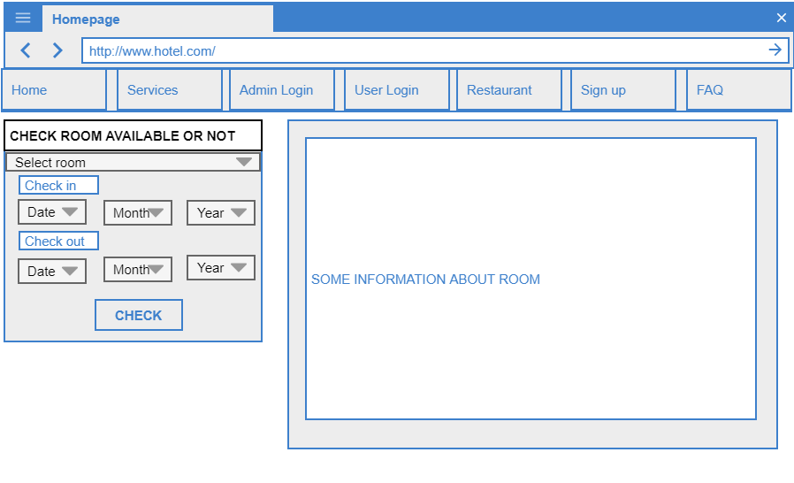

***UI & Business Logics***

| **#** | **Field** | **Description** | **Rule** |
| --- | --- | --- | --- |
| 1 | Lable "Check room avail or not" | Check room in range of check in and check out | * Label |
| 2 | Select room | Combobox show list of room | * On click, dropdown, show list room, combobox |
| 3 | Check in | Check in date | * Label |
| 4 | Check out | Check out date | * Label |
| 5 | Date, month, year | Users select date, month, year…. | * On click, dropdown, show date, month, year, combobox |
| 6 | Navigator | A nav show option for user to switch (Admin - Customer) | * Onclick, nav tag |
| 7 | Some information about room | Include: title, picture to describe room, hotel | * Label |

## 2.2 Function Admin Login

|  |  |
| --- | --- |
| Navigation Path | Homepage --- > Navigator ---> Admin Login---> Screen log in |
| Purpose | This screen only show the interface of admin login |

***Screen layout***

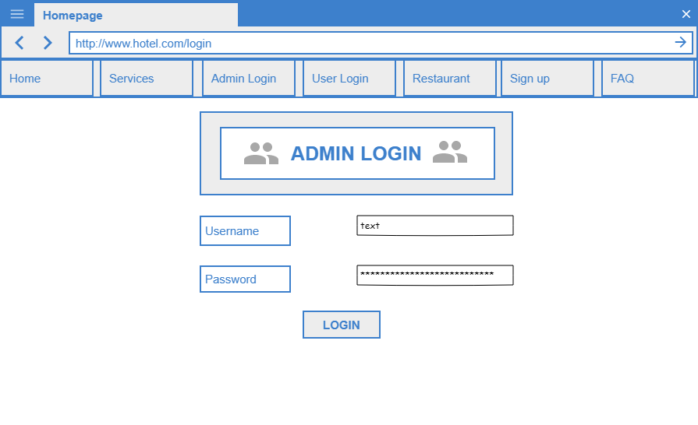

***UI & Business Logics***

|  |  |  |  |
| --- | --- | --- | --- |
| **#** | **Field** | **Description** | **Rule** |
| 1 | Label "Username" | Only label | * Label ( Read only ) |
| 2 | Label "Password" | Only label | * Label ( Read only ) |
| 3 | Button "Login" | Use to click submit form | * Label |
| 4 | Textbox "username" | User will type here to fill username | * Textbox |
| 5 | Textbox "password" | User will type here to fill pass | * Textbox |

## 2.3 Function User Login

|  |  |
| --- | --- |
| Navigation Path | Homepage --- > Navigator ---> User Login---> Screen log in |
| Purpose | This screen only show the interface of user login |

***Screen layout***

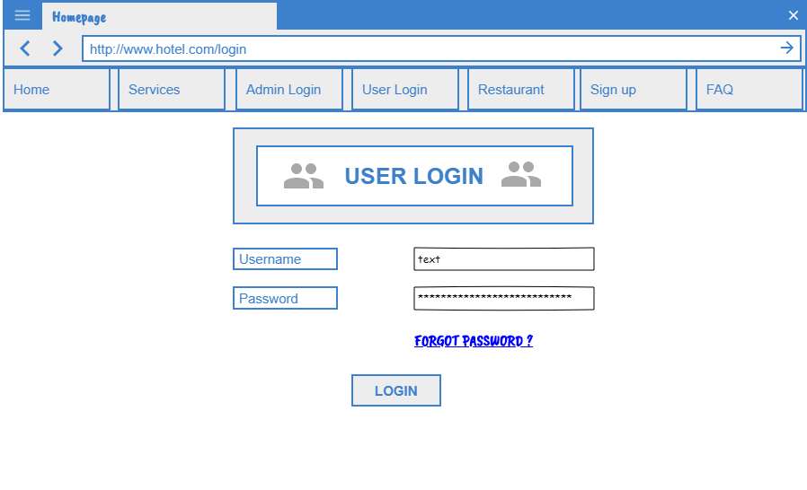

***UI & Business Logics***

|  |  |  |  |
| --- | --- | --- | --- |
| **#** | **Field** | **Description** | **Rule** |
| 1 | Label "Username" | Only label | * Label ( Read only ) |
| 2 | Label "Password" | Only label | * Label ( Read only ) |
| 3 | Button "Login" | Use to click submit form | * Label |
| 4 | Textbox "username" | User will type here to fill username | * Textbox |
| 5 | Textbox "password" | User will type here to fill pass | * Textbox |
| 6 | Nav "Forgot pass" | Forward to forgot pass page | * Navigator tag |

## 2.4 Financial

|  |  |
| --- | --- |
| Navigation Path | Homepage --- > Login Admin -- > Financial |
| Purpose | This screen show financial management |

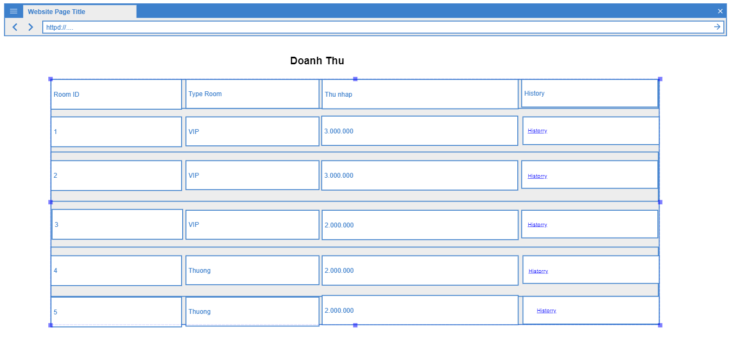

## 2.5

|  |  |
| --- | --- |
| Navigation Path | Homepage --- > Login as admin -- >> Financiel --- > History |
| Purpose | This screen show the financial of a book room |

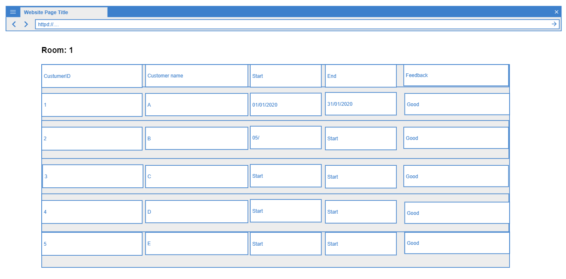

## 2.6 User order food

|  |  |
| --- | --- |
| Navigation Path | Homepage --- > Login as user-- >> Order--- > Food |
| Purpose | This screen show the food list |

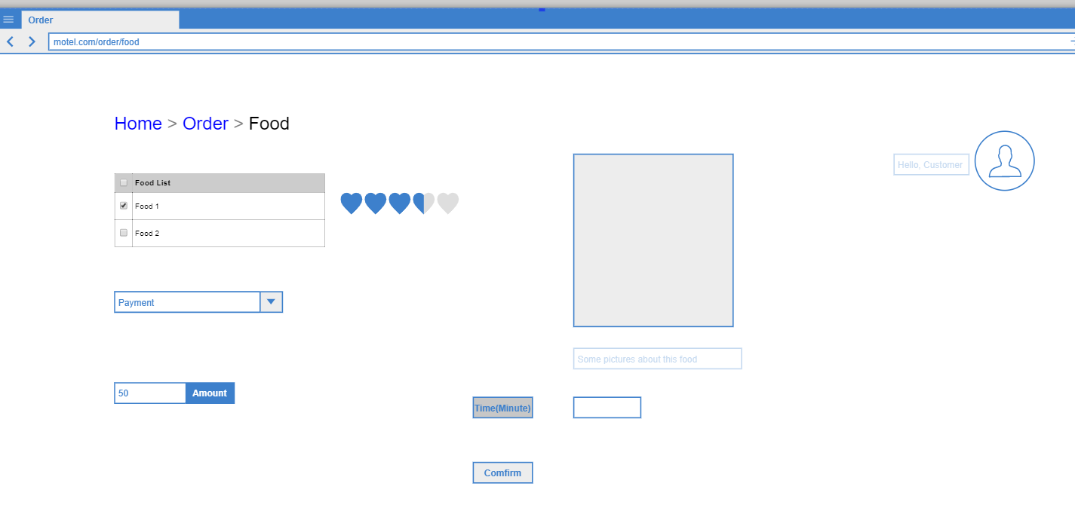

|  |  |  |  |
| --- | --- | --- | --- |
| **#** | **Field** | **Description** | **Rule** |
| 1 | Food list | Only label | * Label ( Read only ) |
| 2 | Check box | Only label | * Check box can tick |
| 3 | Button "Confirm" | Use to click submit form | * Label |
| 4 | Textbox "Time" | User will type here to fill time to ship | * Textbox |
| 5 | Rate | Show food rate | * Read only |

## 2.7 Admin accept order

|  |  |
| --- | --- |
| Navigation Path | Homepage --- > Login as admin-- >> Order--- > Food Pending |
| Purpose | This screen show the food list |

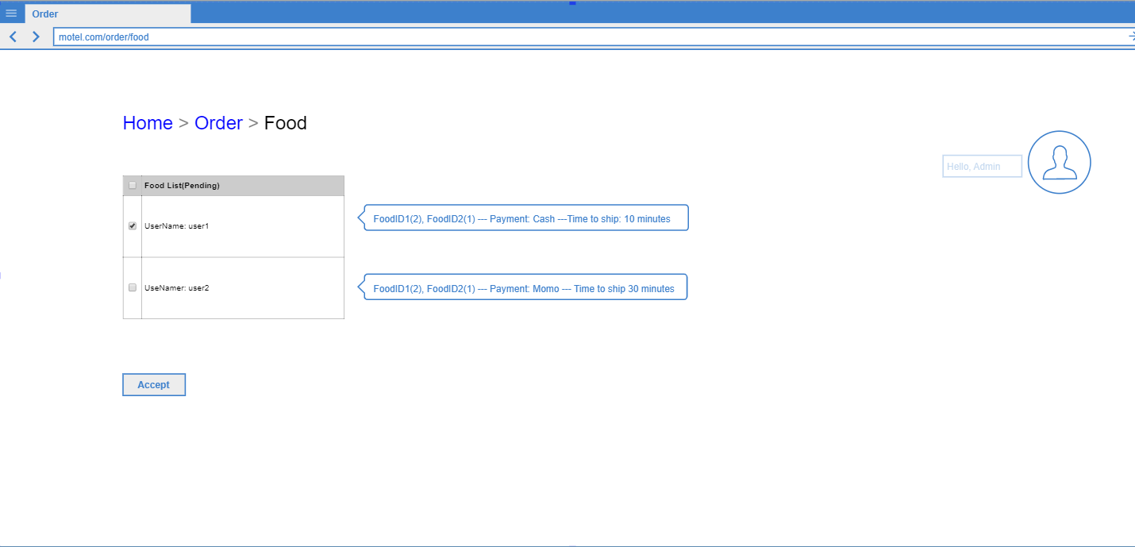

|  |  |  |  |
| --- | --- | --- | --- |
| **#** | **Field** | **Description** | **Rule** |
| 1 | Food list | Only label | * Label ( Read only ) |
| 2 | Check box | Only label | * Check box can tick |
| 3 | Button "Accpect" | Admin to click accept form | * Label |
| 4 | Textbox "Details" | Show details food | * Textbox |

## 2.8: View room

|  |  |
| --- | --- |
| Navigation Path | Homepage --- > View room |
| Purpose | This screen only show the interface of book room or check avalilable |

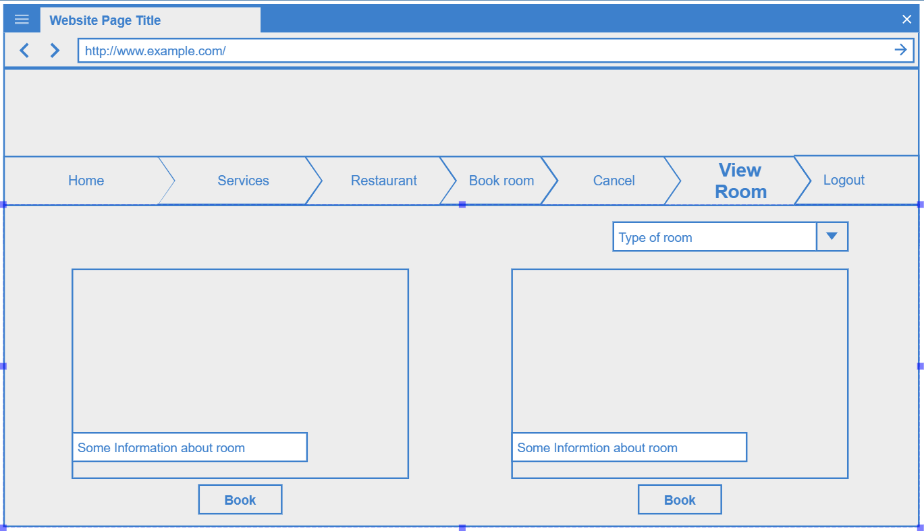

|  |  |  |  |
| --- | --- | --- | --- |
| **#** | **Field** | **Description** | **Rule** |
| 1 | Type of room | Type of room (vip or not vip) | * ComboBox |
| 2 | Some information about room | Bank number | * Label |
| 3 | Book | Booking confirmation | * Botton, onclick |

## 2.9 Book Room

|  |  |
| --- | --- |
| Navigation Path | Homepage --- > Book Room or Hompage ---> Home ---> Book Room |
| Purpose | This screen only show the interface of book room or check avalilable |

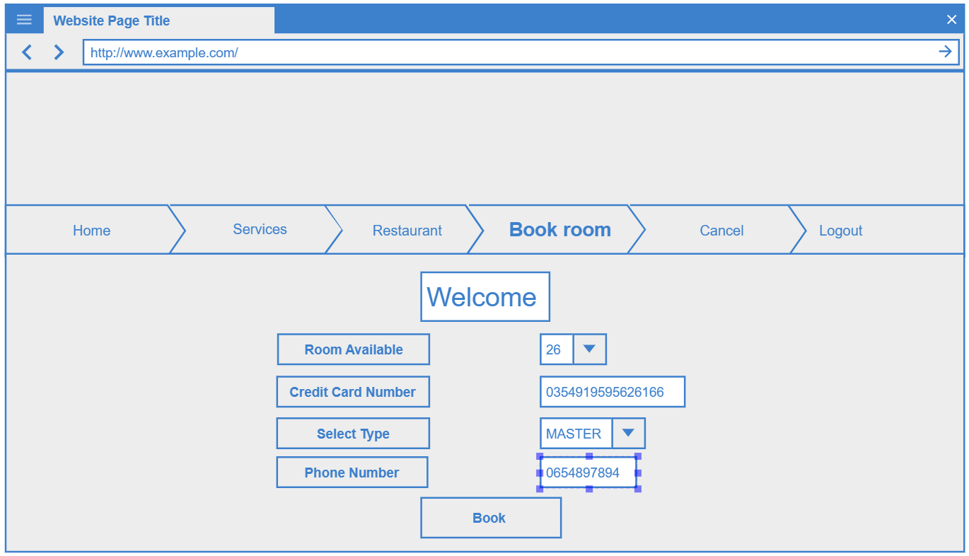

|  |  |  |  |
| --- | --- | --- | --- |
| **#** | **Field** | **Description** | **Rule** |
| 1 | Room Avalilable | Room number | * ComboBox |
| 2 | Credit card number | Bank number | * Label |
| 3 | Select Type | Choose a bank type | * ComboBox |
| 4 | Book | Text Show guest name check out | * Botton, onclick |
| 5 | Phone Number | Phone Number | * Label |

## 2.9 Function check out

|  |  |
| --- | --- |
| Navigation Path | Homepage --- > Check out |
| Purpose | This screen only show the interface of check out |

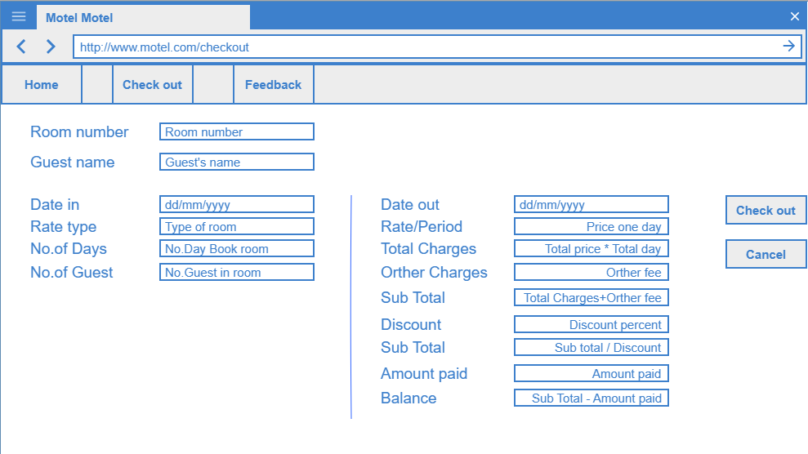

|  |  |  |  |
| --- | --- | --- | --- |
| **#** | **Field** | **Description** | **Rule** |
| 1 | Lable "Room number" | Room number check out | * Label |
| 2 | Text ”Room number” | Text show number room check out | * Text (Read only) |
| 3 | Lable “Guest name” | Guest’s name check out | * Label |
| 4 | Text “Guest name” | Text Show guest name check out | * Text (Read only) |
| 5 | Lable “Date in” | Date guest book room | * Label |
| 6 | Text ”Date in” | Text show date guest book room | * Text (Readonly) |
| 7 | Lable ”Rate type” | Type of room user book | * Label |

## 2.10 Function feedback

|  |  |
| --- | --- |
| Navigation Path | Homepage --- > Check out --- > Feed back |
| Purpose | This screen only show the interface of feed back |

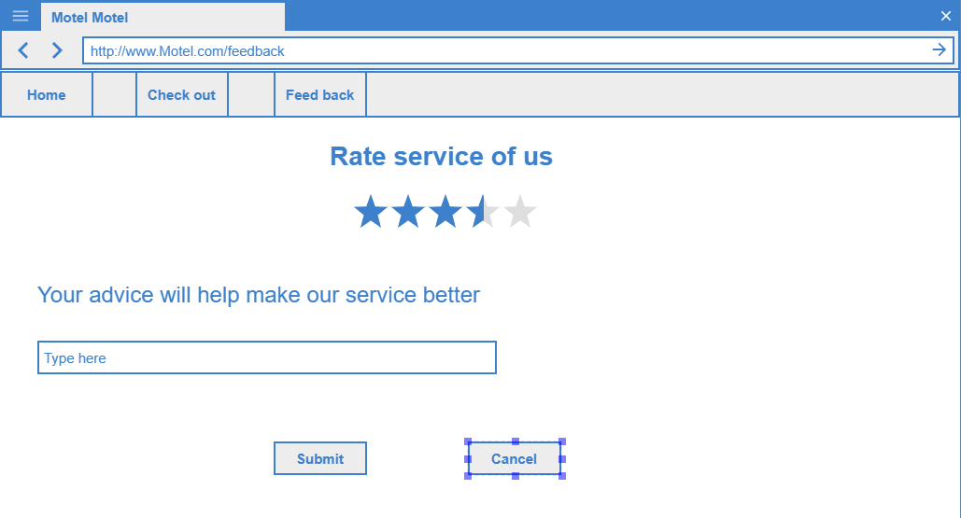

|  |  |  |  |
| --- | --- | --- | --- |
| **#** | **Field** | **Description** | **Rule** |
| 1 | Lable "Rate service of us" | Guest rate service of motel | * Label |
| 2 | Rate star | Rate service of motel by star | * Rate start |
| 3 | Lable “Your advice” | Guest type their advice to motel by text | * Label |
| 4 | Text “Type here” | Space to type advice of guest | * Text |
| 5 | Button “Submit” | Guest finish feed back | * Button |
| 6 | Button “Cancel” | Guest cancel feed back | * Button |

# IV. Data Requirements

## 1. Logical Data Model

*Data model motel are created as an entity-relationship diagram. It’s a visual representation of the data objects and collections the system will process and the relationships between Admin and User*

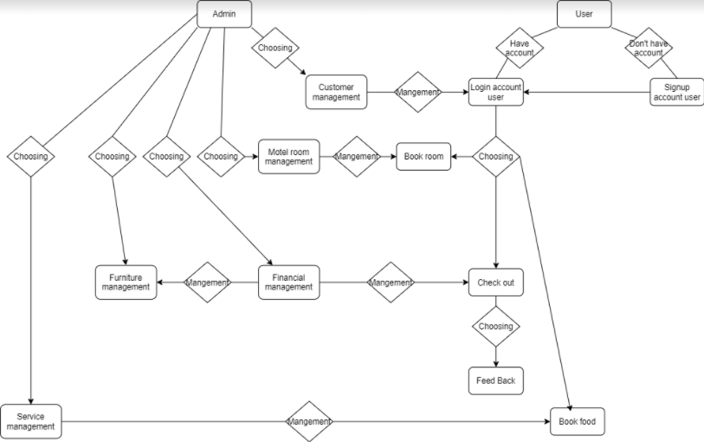

## 2. Data Dictionary

|  |  |  |  |  |
| --- | --- | --- | --- | --- |
| Data Element | Description | Composition or Data Type | Length | Values |
| Account user | It's for users to use the website, and for the admin to manage user information. | +User ID  +User Name  +Email  +Phone Number |  |  |
| User ID | To manage user, to recognize user duplicate name | integer | 6 |  |
| User Name | To manage user | string | 30 | Accented names are allowed, space is allowed |
| Email | To update accommodation information and notice of payment of accommodation charges | string | 30 | Like an email form |
| Phone Number | Directly connect users as needed | string | 20 | Allow + or 0 in font of |
| Order food | To order food in motel | + Order number  + Food’s name  + Price food  + Quantity  + Waiting time  + Note |  |  |
| Order number | Food order number | Int | 6 |  |
| Food’s name | Name of food (To order) | string | 50 | Accented names are allowed |
| Price food | The price of the dish | integer | 10 |  |
| Waiting time | Time to wait for a dish | time | hh:mm | Locate time; hh=0-23 inclusive, mm=00-60 inclusive |
| Note | User can write request | text | 1000 | Accented words are allowed |
| Manage customer | Manage information of user | Account user |  |  |
| Manage room | Manage room list | +Room number  +Furniture  + Consumption electric  + Consumption water |  |  |
| Furniture | Furniture list | +Furniture name  +Quantity  +Price |  |  |
| Furniture name | Name of the furniture in room | string | 20 | Accented words are allowed |
| Quantity | The amount of furniture | int | 6 |  |
| Price | Price of furniture, price of room per month include price consumption electric and water | int | 9 |  |
| Financial manage | Manage financial of motel | +Manage room  +Price |  |  |
| Service manage | Manage service of motel | +Order food |  |  |
| Feedback | User feedback service of motel | text | 1000 |  |

## 3. Reports

### 3.1 Order food Report

|  |  |
| --- | --- |
| Report ID: | COS-RPT-1 |
| Report Title: | Ordered Food |
| Report Purpose: | User check information of food, before decide order food |
| Priority: | Medium |
| Report Users: | User |
| Data Sources: | Database food, price |
| Frequency and Disposition; | Report is generated on demand by User. Data in the report is static. Report is displayed on user's web browser screen on a computer, tablet, or smartphone. |
| Latency: | Complete report must be displayed to User within 3 seconds after it is requested. |
| Visual Layout: | None |
| Header and Footer: | Report header shall contain the report title, User's name, food name, price, waiting time. |
| Report Body: | Fields shown and column headings:   * Order Number * Food Name * Price * Quantity * Total Food Price * Note |
| End-of-Report Indicator: | None |
| Interactivity: | None |
| Security Access Restrictions: | A User may retrieve only his own food order |

# V. Non-Functional Requirements

## 1. External Interface Requirements

<This section provides information to ensure that the system will communicate properly with users and with external hardware or software elements.>

* You need to use smartphone with good internet or 3G/4G to communicate with system
* If the system have owner app, you need install to checkout money when return room

### 1.1 User Interfaces

*<Describe the logical characteristics of each interface between the software product and the users. This may include sample screen images, any GUI standards or product family style guides that are to be followed, screen layout constraints, standard buttons and functions (e.g., help) that will appear on every screen, keyboard shortcuts, error message display standards, and so on. Define the software components for which a user interface is needed. Details of the user interface design should be documented in a separate user interface specification.>*

UI-1: The Hotel management show the interface for user to interact with it

UI-2: Before using system, system will show the tutorial for user to use system

UI-3: User will use phone to communicate with system

UI-4: The Hotel management show the interface for admin, admin use keyboard and mouse to interact with system

### 1.2 Software Interfaces

*<Describe the connections between this product and other software components (identified by name and version), including other applications, databases, operating systems, tools, libraries, websites, and integrated commercial components. State the purpose, formats, and contents of the messages, data, and control values exchanged between the software components. Specify the mappings of input and output data between the systems and any translations that need to be made for the data to get from one system to the other. Describe the services needed by or from external software components and the nature of the intercomponent communications. Identify data that will be exchanged between or shared across software components. Specify nonfunctional requirements affecting the interface, such as service levels for responses times and frequencies, or security controls and restrictions.>*

SI-1: The book room system

SI-1.1: The HMS will check if room expire, if expire, the system will send message

to user to notify them

SI-1.2: If user want to stay more, user will log to system and admin accept.

SI-2: The manager system: furniture, food, financial, hotel room in each unit, customer

SI-2.1: To book food if user want

SI-2.2: To help admin manage furniture in hotel.

SI-2.3: To help admin manage all room in hotel.

SI-2.4: To manage customer: add, remove, update, ….

SI-2.5: To help admin manage financial.

### 1.3 Hardware Interfaces

*<Describe the characteristics of each interface between the software and hardware (if any) components of the system. This description might include the supported device types, the data and control interactions between the software and the hardware, and the communication protocols to be used. List the inputs and outputs, their formats, their valid values or ranges, and any timing issues developers need to be aware of. If this information is extensive, consider creating a separate interface specification document.>*

No hardware interfaces have been identified.

### 1.4 Communications Interfaces

*<State the requirements for any communication functions the product will use, including e-mail, Web browser, network protocols, and electronic forms. Define any pertinent message formatting. Specify communication security or encryption issues, data transfer rates, handshaking, and synchronization mechanisms. State any constraints around these interfaces, such as whether e-mail attachments are acceptable or not.>*

CI-1: Gmail, social media

CI-2: Laptop, phone

## 2. Quality Attributes

### 2.1 Usability

*[This section includes all those requirements that affect usability. For example, specify the required training time for a normal user and a power user to become productive at particular operations specify measurable task times for typical tasks or base the new system’s usability requirements on other systems that the users know and like specify requirement to conform to common usability standards, such as IBM’s CUA standards Microsoft’s GUI standards]*

### 2.2 Reliability

*[Requirements for reliability of the system should be specified here. Some suggestions follow:*

*Availability—specify the percentage of time available ( xx.xx%), hours of use, maintenance access, degraded mode operations, and so on.*

*Mean Time Between Failures (MTBF) — this is usually specified in hours, but it could also be specified in terms of days, months or years.*

*Mean Time To Repair (MTTR)—how long is the system allowed to be out of operation after it has failed?*

*Accuracy—specifies precision (resolution) and accuracy (by some known standard) that is required in the system’s output.*

*Maximum Bugs or Defect Rate—usually expressed in terms of bugs per thousand lines of code (bugs/KLOC) or bugs per function-point( bugs/function-point).*

*Bugs or Defect Rate—categorized in terms of minor, significant, and critical bugs: the requirement(s) must define what is meant by a “critical” bug; for example, complete loss of data or a complete inability to use certain parts of the system’s functionality.]*

### 2.3 Performance

*[The system’s performance characteristics are outlined in this section. Include specific response times. Where applicable, reference related Use Cases by name.*

*Response time for a transaction (average, maximum)*

*Throughput, for example, transactions per second*

*Capacity, for example, the number of customers or transactions the system can accommodate*

*Degradation modes (what is the acceptable mode of operation when the system has been degraded in some manner)*

*Resource utilization, such as memory, disk, communications, and so forth.*

### 2.4 Dependability

*<< Software dependability includes a range of characteristics including reliability, security and safety. Dependable software should not cause physical or economic damage in the event of system failure. Malicious users should not be able to access or damage the system>>*

#### a. Security

*<Specify any requirements regarding security or privacy issues that restrict access to or use of the product. These could refer to physical, data, or software security. Security requirements often originate in business rules, so identify any security or privacy policies or regulations to which the product must conform. If these are documented in a business rules repository, just refer to them.>*

* *Firewall*

#### b. Safety

*<Specify requirements that are concerned with possible loss, damage, or harm that could result from use of the product. Define any safeguards or actions that must be taken, as well as potentially dangerous actions that must be prevented. Identify any safety certifications, policies, or regulations to which the product must conform.>*

* *Hacker*

### 2.5 Supportability

*[This section indicates any requirements that will enhance the supportability or maintainability of the system being built, including coding standards, naming conventions, class libraries, maintenance access, and maintenance utilities.]*

### 2.6 Design Constraints

*[This section indicates any design constraints on the system being built. Design constraints represent design decisions that have been mandated and must be adhered to. Examples include software languages, software process requirements, prescribed use of developmental tools, architectural and design constraints, purchased components, class libraries, and so on.]*

### 2.7 Support Documents

*[Describes the requirements, if any, for o-line user documentation, help systems, help about notices, and so forth.]*

*<https://www.hotelogix.com/>*

*<https://www.softwareadvice.com/hotel-management/>*

*<https://blog.capterra.com/the-5-most-popular-hotel-management-software-solutions-for-small-hotels-compared/>*

*<https://www.pureautomate.com/>*

### 2.8 Purchased Components

*[This section describes any purchased components to be used with the system, any applicable licensing or usage restrictions, and any associated compatibility and interoperability or interface standards.]*

# VI. Other Requirements

*<Examples are: legal, regulatory or financial compliance, and standards requirements; requirements for product installation, configuration, startup, and shutdown; and logging, monitoring and audit trail requirements. Instead of just combining these all under "Other," add any new sections to the template that are pertinent to your project. Omit this section if all your requirements are accommodated in other sections. >*

## 1. Appendix1 - Messages List

|  |  |  |  |  |
| --- | --- | --- | --- | --- |
| **#** | **Message code** | **Message Type** | **Context** | **Content** |
| 1 | MSG01 | In line | Khi không có kết quả tìm kiếm | *No search result.* |
| 2 | MSG02 | Màu đỏ, phía dưới text box | Khi user để trống các trường bắt buộc | *The * field is required.* |
| 3 | MSG03 | Toast message | Khi tạo account thành công | *Create account successfully.* |
| 4 | MSG04 | Toast message | Khi đặt phòng thành công | *Booking room successfully.* |
| 5 | MSG05 | Toast message | Khi email xác nhận nhận đặt phòng thành công | *A confirmation email has been sent to {email_address}.* |
| 6 | MSG06 | Toast message | Khi nhập thêm phòng thành công | *Add room successfully.* |
| 7 | MSG07 | Toast message | Khi xóa phòng đã đặt thành công | *Delete room booked successfully.* |
| 8 | MSG08 | Toast message | Khi user tìm phòng không tồn tại | *Room is not exist* |
| 9 | MSG09 | In line | Khi user nhập tên hoặc mật khẩu không đúng và sign in | *Incorrrect user name or password. Please check again.* |

## 2. Appendix2 - …